Bahria University,

Karachi Campus

LAB EXPERIMENT NO.

**14**

LIST OF TASKS

|  |  |
| --- | --- |
| TASK NO | OBJECTIVE |
|  |  |
| 1 | What is the difference between Flip-Flop and latch? |
| 2 | What is the difference between synchronous and asynchronous inputs? |
| 3 | What are the applications of different Flip-Flops? |
| 4 | What is the difference of Edge triggering over level triggering? |
| 5 | Make circuits of SR, JK, D, and T flip flop. (Example) |

Submitted On:

4/1/2023

(Date: DD/MM/YY)

Q 1 :What is the difference between Flip-Flop and latch?

ANSWER:

The major difference between flip-flop and latch is that the flip-flop is an edge-triggered type of memory circuit while the latch is a level-triggered type. It means that the output of a latch changes whenever the input changes

Q 2 :What is the difference between synchronous and asynchronous inputs?

ANSWER:

In the synchronous counter there are continuous clock input signals with flip-flops used to produce the output. In Asynchronous counters there are different clock signals used to produce the output.

Q 3 :What are the applications of different Flip-Flops?

ANSWER

**Applications of Flip-Flops**

* Frequency dividers.
* Counters.
* Storage registers.
* Shift registers.
* Data storage.
* Bounce elimination switch.
* Latch.
* Data transfer.

Q 4 : What is the difference of Edge triggering over level triggering?

ANSWER

Edge triggering is a type of triggering that allows a circuit to become active at the positive edge or the negative edge of the clock signal. In contrast, level triggering is a type of triggering that allows a circuit to become active when the clock pulse is on a particular leve

Make circuits of SR, JK, D, and T flip flop. (Example)

**SR FLIP FLOP**

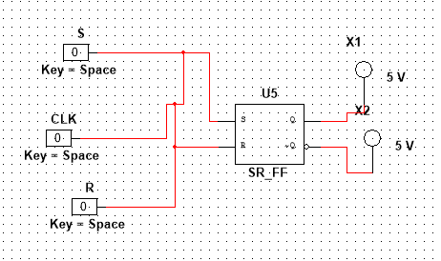

**JK FLIP FLOP**

**T FLIP FLOP**

**D FLIP FLOP**

